Competency Based Question (PISA)
The Government of India spent a total of Rs.500 crore for the development of various sectors, the percentage of which is given in the form of Pie chart.

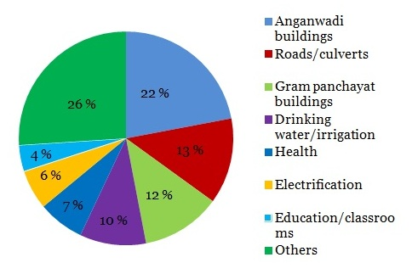
Question .1 How many Rs. are Spent on the Gram panchayat building?
- Rs 50 Crore (B) Rs. 60 Crore (C) Rs. 130 Crore
Question.2 How many Rs. are spent on the others sources?
- Rs.130 Crore (B) Rs.60 crore (C) Rs.50 crore
Question .3 Which Area was spent on Rs.20 crore Rupey?
- Education/classroom (B) Health (C) Drinking water

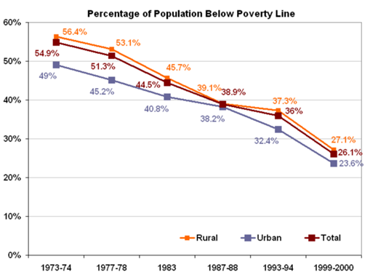

Look at the above chart carefully and answer the following question
Question.1 In which of the following year is the maximum percentage of rural poverty?
- 1977-78 (B) 1973-74 (C) 1999-2000 (D) 1987-88
Question.2 In which of the following years is the minimum percentage of rural poverty?
- 1977-78 (B) 1973-74 (C) 1999-2000 (D) 1987-88
Question.3 In which of the following years is the maximum percentage of urban poverty?
- 1977-78 (B) 1973-74 (C) 1999-2000 (D) 1987-88
Question.4 In which of the following years is the minimum percentage of total poverty?
(A) 1977-78 (B) 1973-74 (C) 1999-2000 (D) 1987-88

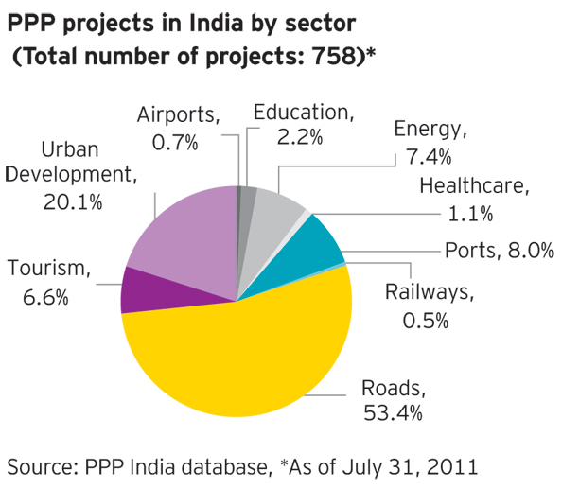

Look at the above pie chart carefully and answer the following question

Question.1How many projects are there in the following roads?
- 256 (B) 360 (C) 400 (D) 405
Question.2 how many projects are involved in urban development?
- 98 (B) 152 (C) 120 (D) 150
Question.3 About 17 Projects are in which of the following areas?
- Health (B) Energy (C) Tourism (D) Education
Question.4 About 50 Projects are in which of the following areas?
- Health (B) Energy (C) Tourism (D) Education

